**NAMA: Andriansyah Rio Alfatah**

**Kelompok : 2**

**Bagian 2a Transform : Intermediate Queries**

1. Tulis query untuk mendapatkan jumlah customer tiap bulan yang melakukan order pada tahun 1997.

SELECT MONTH(OrderDate) AS MONTH_ORDER, COUNT(DISTINCT CustomerID) AS COUNT_CUSTOMER FROM dbo.Orders

WHERE YEAR(OrderDate) = 1997

GROUP BY MONTH(OrderDate)

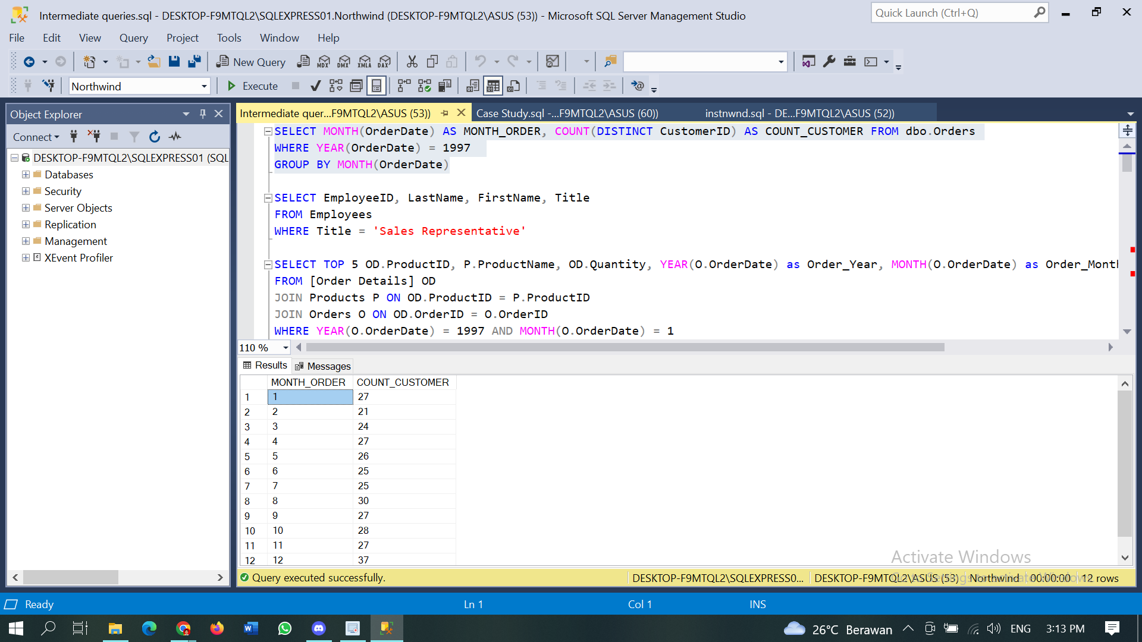

1. Tulis query untuk mendapatkan nama employee yang termasuk Sales Representative.

SELECT EmployeeID, LastName, FirstName, Title

FROM Employees

WHERE Title = 'Sales Representative'

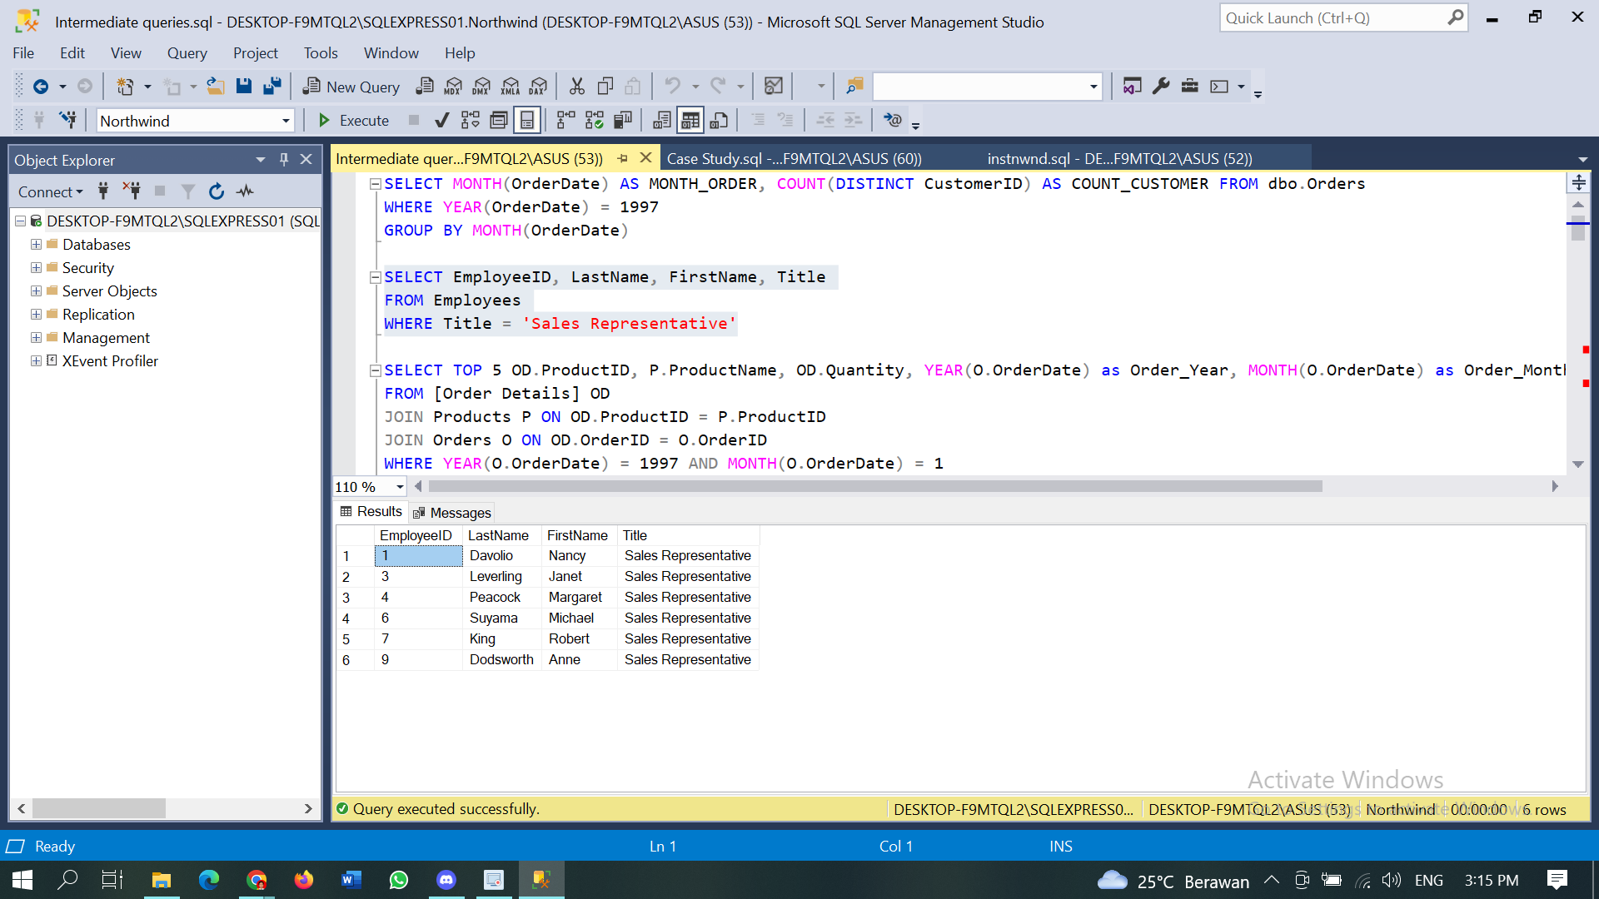

1. Tulis query untuk mendapatkan top 5 nama produk yang quantitynya paling banyak diorder pada bulan Januari 1997.

SELECT TOP 5 OD.ProductID, P.ProductName, OD.Quantity, YEAR(O.OrderDate) as Order_Year, MONTH(O.OrderDate) as Order_Month

FROM [Order Details] OD

JOIN Products P ON OD.ProductID = P.ProductID

JOIN Orders O ON OD.OrderID = O.OrderID

WHERE YEAR(O.OrderDate) = 1997 AND MONTH(O.OrderDate) = 1

ORDER BY OD.Quantity DESC

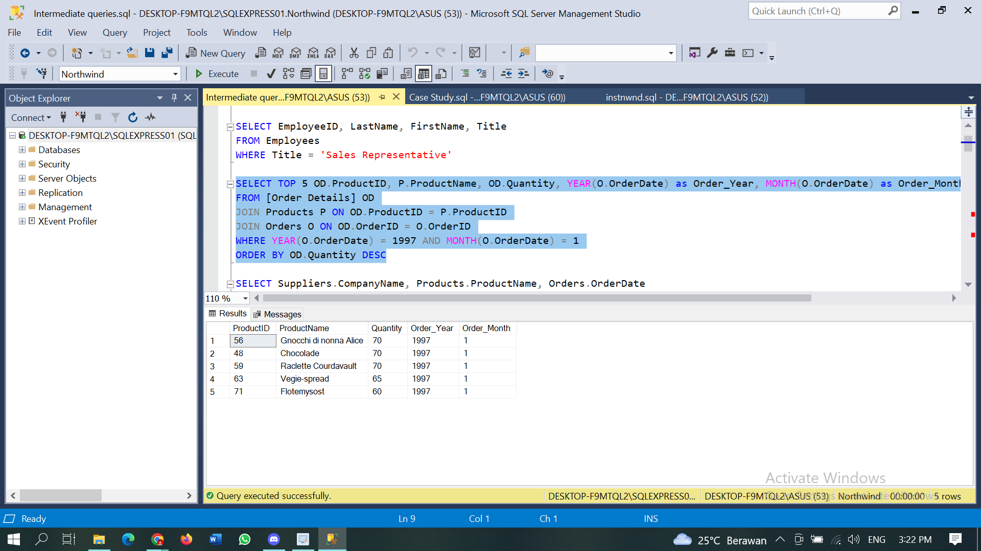

1. Tulis query untuk mendapatkan nama company yang melakukan order Chai pada bulan Juni 1997.

SELECT Suppliers.CompanyName, Products.ProductName, Orders.OrderDate

FROM Products

JOIN Suppliers ON Products.SupplierID = Suppliers.SupplierID

join [Order Details] ON Products.ProductID = [Order Details].ProductID

join Orders On [Order Details].OrderID = Orders.OrderID

WHERE YEAR(Orders.OrderDate) = 1997 AND ProductName = 'Chai'

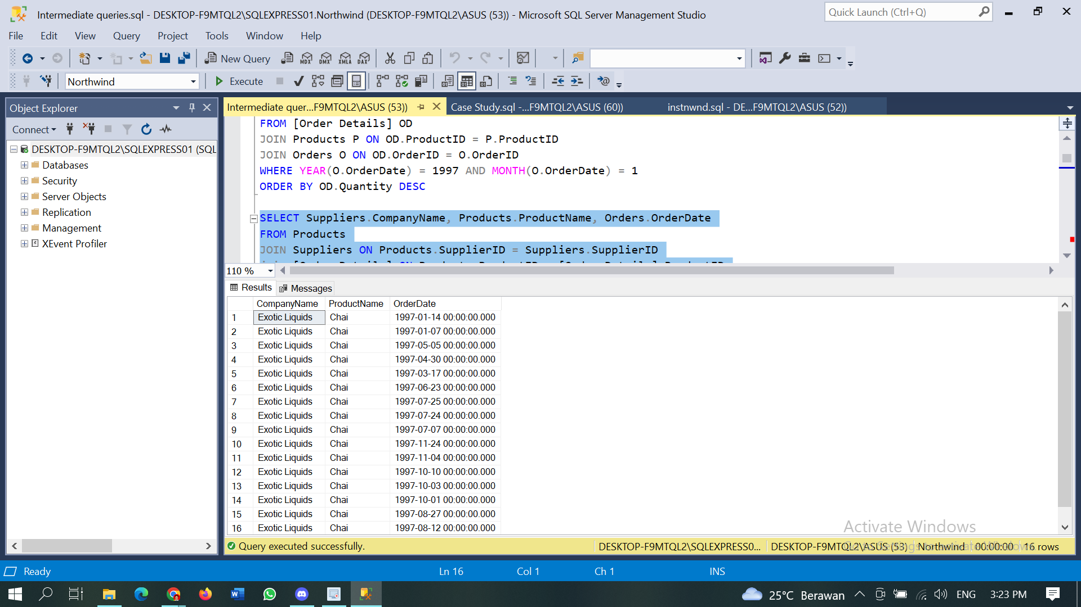

1. Tulis query untuk mendapatkan jumlah OrderID yang pernah melakukan pembelian (unit_price dikali quantity) <=100, 100<x<=250, 250<x<=500, dan >500.

WITH purchase_summary AS (

SELECT

[Order Details].OrderID,

SUM([Order Details].UnitPrice * [Order Details].Quantity) as total_purchase

FROM [Order Details]

JOIN Orders ON [Order Details].OrderID = Orders.OrderID

GROUP BY [Order Details].OrderID

)

SELECT

SUM(CASE WHEN total_purchase <= 100 THEN 1 ELSE 0 END) as purchase_under_100,

SUM(CASE WHEN total_purchase > 100 AND total_purchase <= 250 THEN 1 ELSE 0 END) as purchase_between_100_250,

SUM(CASE WHEN total_purchase > 250 AND total_purchase <= 500 THEN 1 ELSE 0 END) as purchase_between_250_500,

SUM(CASE WHEN total_purchase > 500 THEN 1 ELSE 0 END) as purchase_over_500

FROM purchase_summary

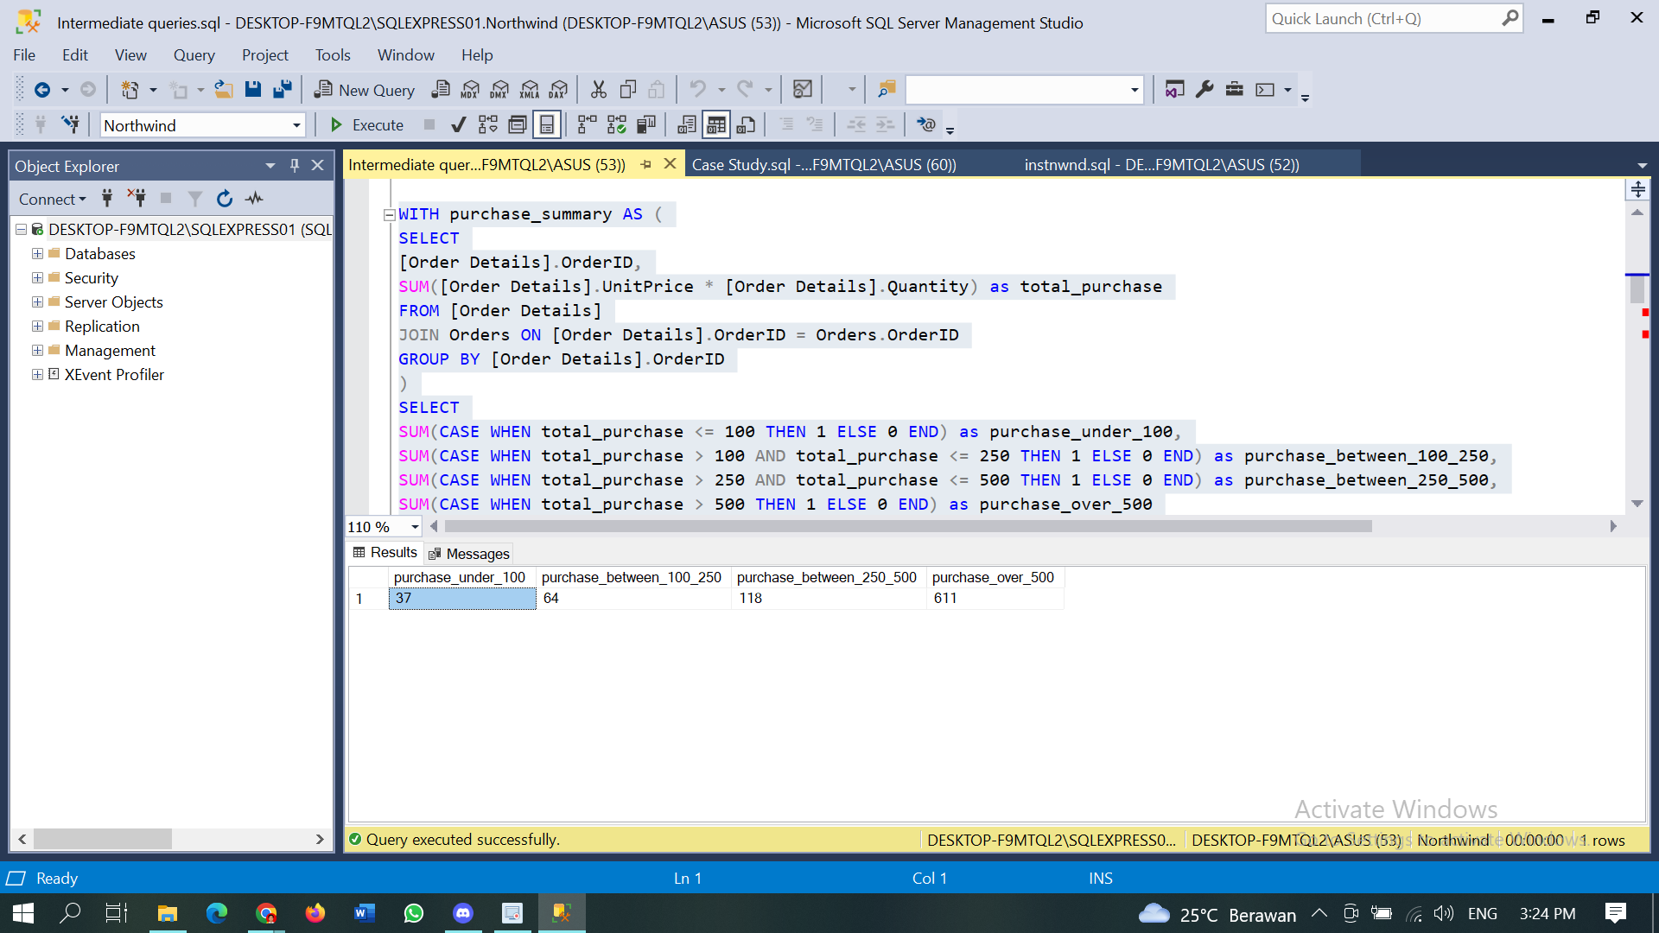

1. Tulis query untuk mendapatkan Company name pada tabel customer yang melakukan pembelian di atas 500 pada tahun 1997.

Select Customers.CompanyName, SUM ([Order Details].Quantity) AS QUANTITY

FROM Customers

join Orders on Customers.CustomerID = Orders.CustomerID

join [Order Details] on Orders.OrderID = [Order Details].OrderID

where YEAR(Orders.OrderDate) = 1997

group by Customers.CompanyName

having SUM ([Order Details].Quantity) > 500

ORDER BY SUM ([Order Details].Quantity)

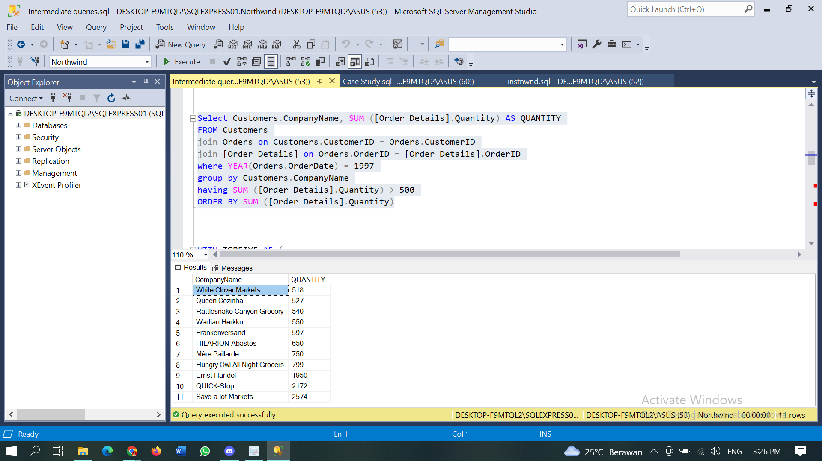

1. Tulis query untuk mendapatkan nama produk yang merupakan Top 5 sales tertinggi tiap bulan di tahun 1997.

WITH TOPFIVE AS (

SELECT Products.ProductName, MONTH(orders.OrderDate) as Month, SUM([Order Details].Quantity ) as TotalSales,

ROW_NUMBER() OVER (PARTITION BY MONTH(orders.OrderDate) ORDER BY SUM([Order Details].Quantity ) DESC) as RowNo

FROM Orders

JOIN [Order Details] ON Orders.OrderID = [Order Details].OrderID

JOIN Products ON [Order Details].ProductID = Products.ProductID

WHERE YEAR(OrderDate) = 1997

GROUP BY Products.ProductName, MONTH(orders.OrderDate)

)

SELECT ProductName, Month, TotalSales FROM TOPFIVE WHERE RowNo <= 5

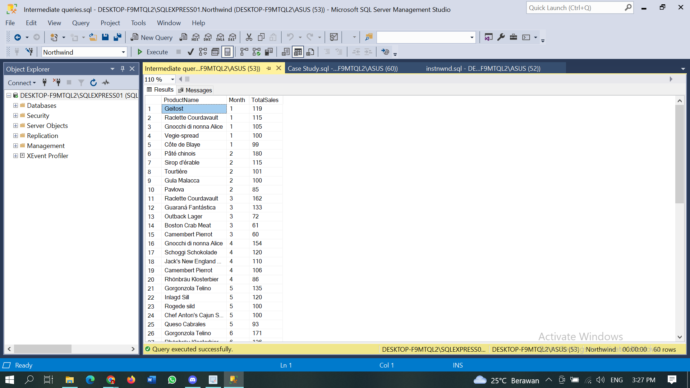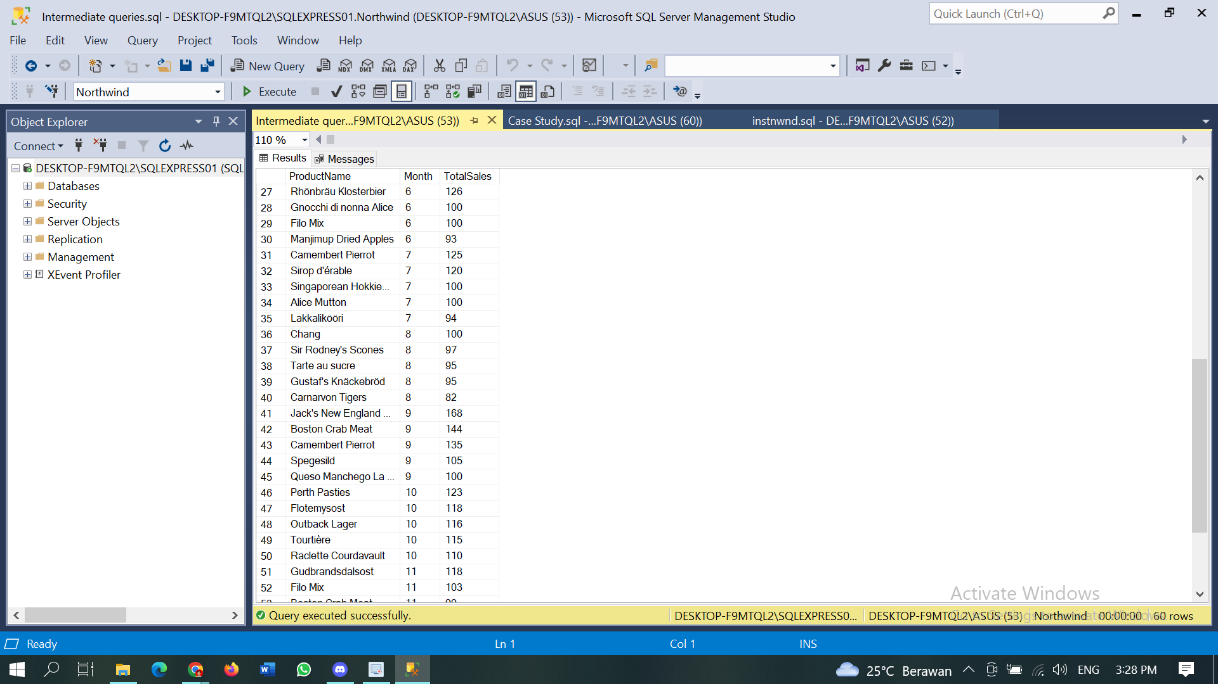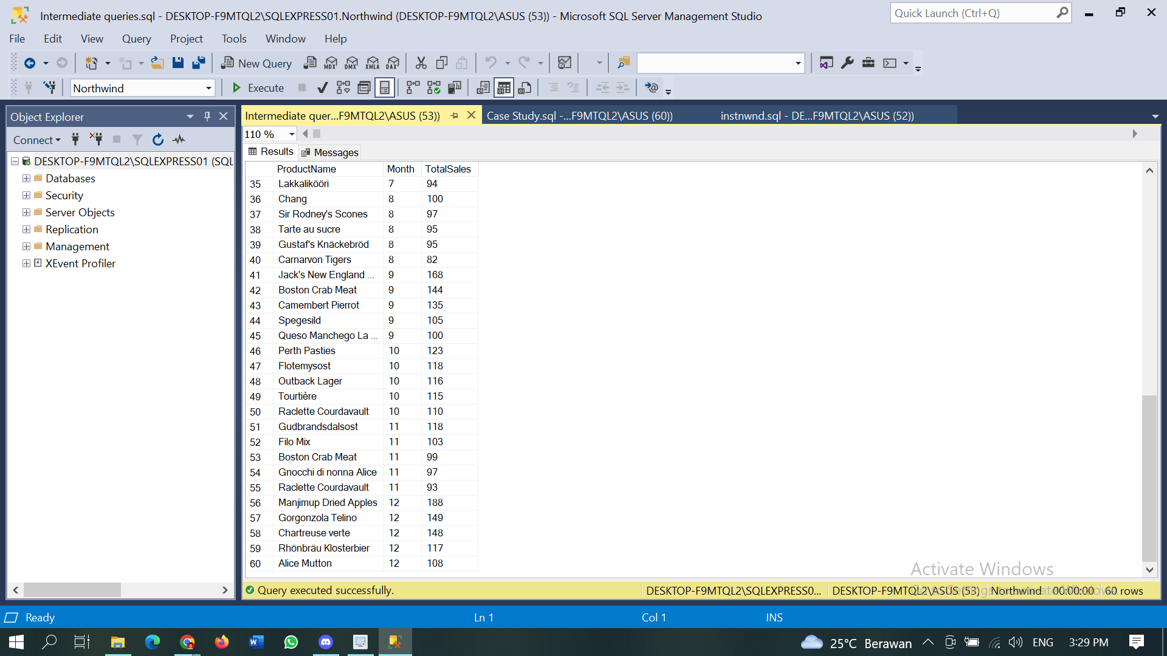

1. Buatlah view untuk melihat Order Details yang berisi OrderID, ProductID, ProductName, UnitPrice, Quantity, Discount, Harga setelah diskon.

CREATE VIEW Order_Details_View AS

SELECT

[Order Details].OrderID,

[Order Details].ProductID,

Products.ProductName,

[Order Details].UnitPrice,

[Order Details].Quantity,

[Order Details].Discount,

([Order Details].UnitPrice * [Order Details].Quantity) - (([Order Details].UnitPrice * [Order Details].Quantity) * [Order Details].Discount) AS Total_After_Discount

FROM [Order Details]

JOIN Products ON [Order Details].ProductID = Products.ProductID

SELECT *

FROM Order_Details_View

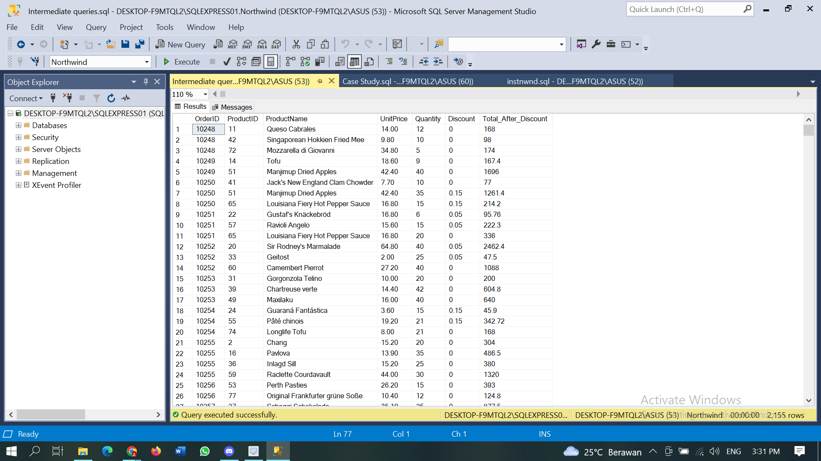

1. Buatlah procedure Invoice untuk memanggil CustomerID, CustomerName/company name, OrderID, OrderDate, RequiredDate, ShippedDate jika terdapat inputan CustomerID tertentu.

CREATE PROCEDURE InvoiceByCustomerID

AS

SELECT Customers.CustomerID, Customers.CompanyName, Orders.OrderID, Orders.OrderDate, Orders.RequiredDate, Orders.ShippedDate

FROM Orders

JOIN Customers ON Orders.CustomerID = Customers.CustomerID

GO

EXEC InvoiceByCustomerID

